LAB 7 Positioning elements using CSS

Objectives

Theoretical Description
Positioning Elements Using CSS

Position Static
By default all elements on the web page are using position:static without even needed to specify it. This is the normal positioning method which is what is used in the normal document flow. Chances are, you’ll never need to specify position:static.

2 Position Relative
If you assign position:relative to an element, what that does is allow you to offset the box precisely to the top, right, bottom, or left by a given amount relative to its original position in the document flow. The space that element would have occupied is preserved and continues to have an effect on the layout of surrounding content.To demonstrate the position Relative technique, we will use the following markup. We remove the floats from our <section> elements so they now stack on top of each other. We also assign a width to the wrapping div, and set the margin to auto so that our <section> elements line up right in the center of the page.
html
<html>
<head>
<title>CSS Positioning Tutorial</title>
<link rel="stylesheet" type="text/css" href="style.css">
</head>
<body>
<div class="container">
<section class="one">
<img src="berries.png" width="200">
Lorem ipsum dolor sit...
</section>
<section class="two">
<img src="forest.png" width="200">
Lorem ipsum dolor sit...
</section>
<section class="three">
<img src="fish.png" width="200">
Lorem ipsum dolor sit...
</section>
</div>
</body>
</html>
Markup
Copy
css
section {
border: 2px solid lightblue;
padding: 10px;
margin: 3px;
}

img {
float: left;
padding-right: 10px;
}

.container {
width: 500px;
margin: auto;
}
CSS
Copy
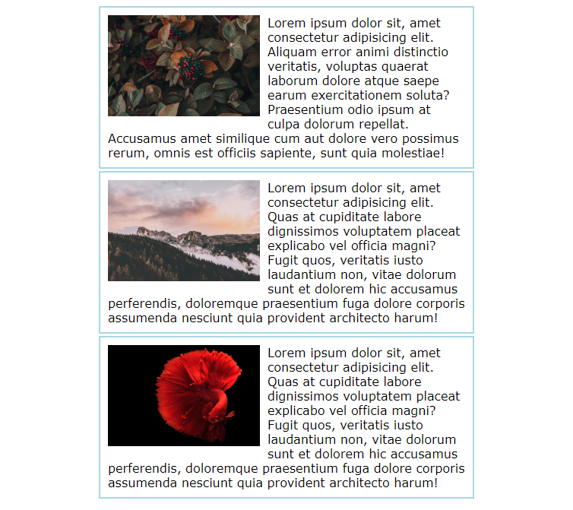
What we want to do now is apply a position:relative to the second <section> so that we can move it relative to where it would normally appear in the document flow. This following CSS says to offset that <section> 100 pixels from the left of where it would have normally appeared. This gives the effect of shifting the <section> 100 pixels to the right.
section.two {
position: relative;
left: 100px;
}
CSS
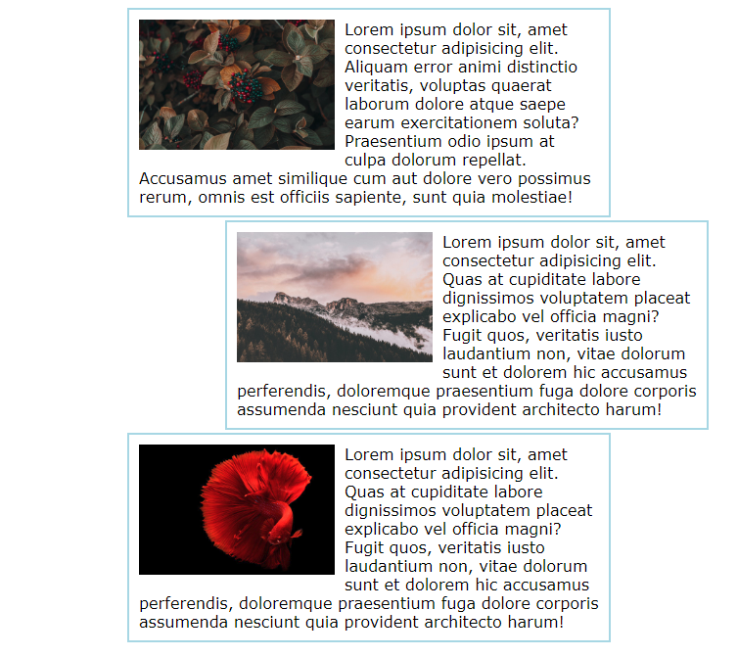
You can also move it to the left by offsetting from the right.
section.two {
position: relative;
right: 100px;
}
CSS
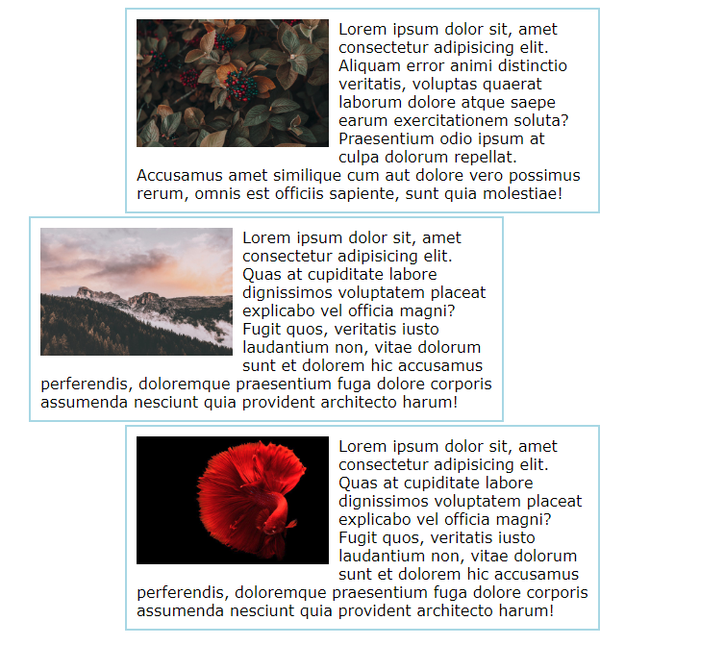
If we were to set either the top or bottom offset, the content would begin to overlap but you get the idea of how this works. It is important to note that when you use position:relative on an element, it is not removed from normal document flow. The element still occupies the original position in the document, it is just offset visually to the end-user. Position relative is very good if you want to simply tweak an element just a bit in the overall layout.
Consider the three sections are now back to a float layout where we have three columns. We could use this CSS to create a neat offset effect vertically now.
section.two {
position: relative;
top: 40px;
}

section.three {
position: relative;
top: 80px;
}
CSS
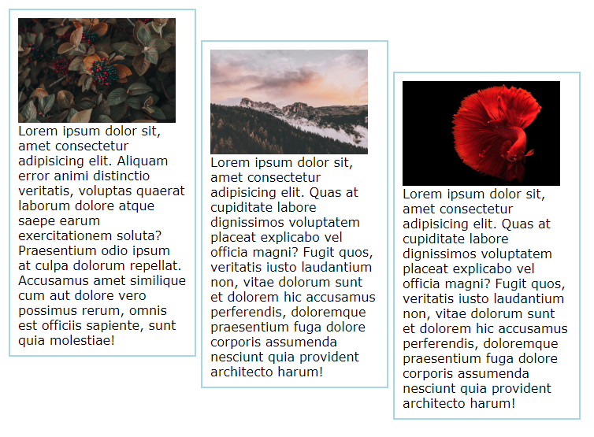
The key points to remember about Relative Positioning are:
- The element remains in the normal document flow
- The original space in the document is preserved
- Be careful for overlapping content as you move the element

Position Absolute
The position:absolute value takes elements out of the normal document flow. This means the element can be placed absolutely anywhere on the web page that the designer chooses. Absolute positioning is likely the most commonly used and versatile of the various positioning methods. Absolutely positioned elements will continue to scroll with the page. The position:absolute value is most often used on an element which has a parent that has its positioning set to position:relative. It’s a little confusing, so let’s see an example.
We will start with just a <div> element which has an <img> and then an <h1> element like so.
html
<html>

<head>
<title>CSS Positioning Tutorial</title>
<link rel="stylesheet" type="text/css" href="style.css">
</head>

<body>
<div class="container">
<div id="banner">
<img src="friends.png" width="100%">
<h1>Hanging Out With Friends</h1>
</div>
</div>
</body>

</html>

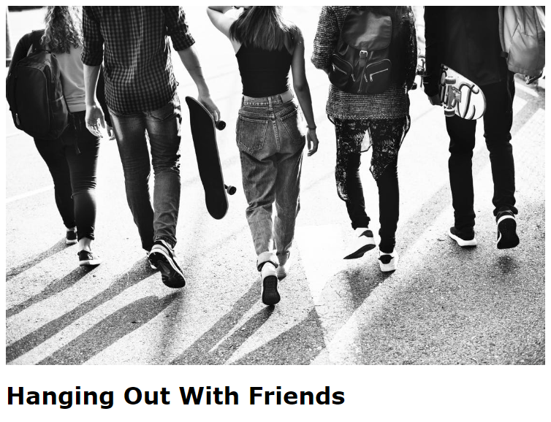
With that in place, our goal is to take that <h1> headline and position it absolutely overlapping the image to give it a cool banner effect. It would almost be like the text itself is part of the banner. This is a two-step process. First, we assign position:relative to the parent of the element we want to absolutely position. So the parent of the <h1> is the div with an id of #banner. Once that is in place, we target the <h1> itself and apply position:absolute.

#banner {
position: relative;
}

h1 {
position: absolute;
bottom: 10px;
left: 140px;
}
CSS
Copy
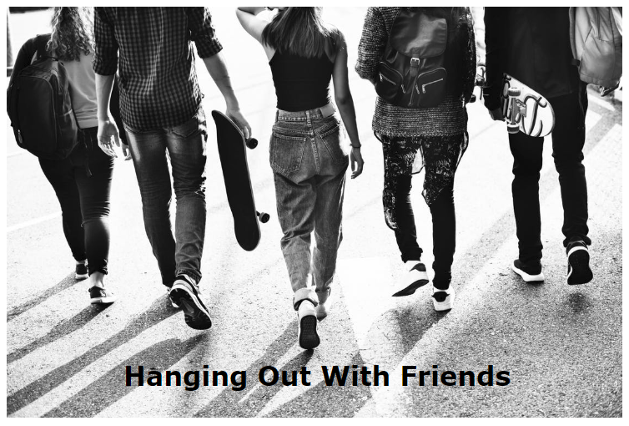
Looks pretty good! Absolutely positioned elements work in conjunction with containing blocks. Since overlap occurs with absolute positioning, you can make use of the z-index to adjust the stacking order of elements on the page to get the result you are looking for. So with Position Absolute, we can remember that:
- The element is taken out of the normal document flow
- The original space in the document is no longer preserved
- Will often use with a parent element whose position is relative

Position Fixed
Position fixed is like taking an element and tacking it directly to the screen. In other words, the element stays fixed in one position in the window even when the user scrolls the page. Of course this means that fixed elements are taken out of the normal document flow and are positioned relative only to the browser window itself. Fixed positioning can get you in to trouble, so be careful with it. One use you might see with fixed positioning however is a fixed navigation bar. Let’s see an example of that.
Here is out HTML which now has a nav area near the top of the page.
<html>

<head>
<title>CSS Positioning Tutorial</title>
<link rel="stylesheet" type="text/css" href="style.css">
</head>

<body>
<nav>
<ul>
<li>Link 1</li>
<li>Link 2</li>
<li>Link 3</li>
<li>Link 4</li>
<li>Link 5</li>
</ul>
</nav>
<div class="container">
<section>
<img src="beach.png" width="200">
Lorem ipsum dolor sit...
</section>
<section>
<img src="berries.png" width="200">
Lorem ipsum dolor sit...
</section>
<section>
<img src="building.png" width="200">
Lorem ipsum dolor sit...
</section>
<section>
<img src="cave.png" width="200">
Lorem ipsum dolor sit...
</section>
<section>
<img src="city.png" width="200">
Lorem ipsum dolor sit...
</section>
<section>
<img src="concert.png" width="200">
Lorem ipsum dolor sit...
</section>
<section>
<img src="design.png" width="200">
Lorem ipsum dolor sit...
</section>
<section>
<img src="lake.png" width="200">
Lorem ipsum dolor sit...
</section>
<section>
<img src="fish.png" width="200">
Lorem ipsum dolor sit...
</section>
<section>
<img src="friends.png" width="200">
Lorem ipsum dolor sit...
</section>
</div>
</body>

</html>
Markup
Our goal is to make this nav bar sticky to it sticks to the top of the page and is visible no matter what, even when scrolling. To do this, we can assign the nav a position of fixed, and then set the top to zero and the left to zero. This effectively sticks this navigation menu to the top of the page, and it will continue to be visible during scrolling. This is a common use case for a fixed positioning.
css
nav {
width: 100%;
background-color: #333;
padding: 20px;
position: fixed;
top: 0;
left: 0;
}
nav li {
list-style-type: none;
margin: 0 10px;
color: white;
float: left;
}
ul::after {
display: block;
content: "";
clear: both;
}

In summary, fixed positioning has these traits:
- The element is removed from normal document flow
- Offset values for fixed elements are always relative to the viewport
- The element retains position even during web page scrolling
Lab Task
Create web pages on any emerging topic using positioning elements

